**EnVision Math Login Instructions for Students (and Teachers)**

**If you or your students are logging into Pearson with a username and password, or if you are clicking an “Easy Bridge Plus” link to log in…**

**YOU ARE DOING IT WRONG!!**

*Please find our EASY login instructions below*:

1. Log into your district Google account (or Gmail)
2. While **still in your Gmail**, go to the Apps button (waffle at the upper right).
3. Click **“More”** at the bottom.
4. Click the **“Easy Bridge”** app icon and you will be taken directly to Pearson. Just click “Realize” in the lower right and you’re there!

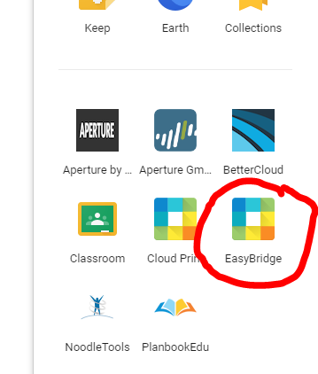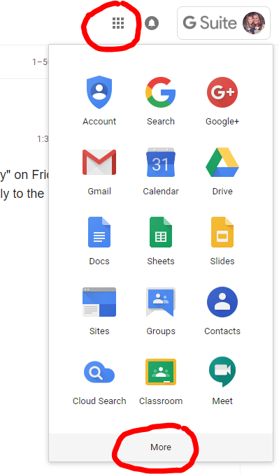

This method also works:

1. Log into your district **Gmail**
2. Open a new tab and go to **holman.jacksonsd.org**
3. At the top of the page, go to “**FOR STAFF**”
4. Click on “Envision Math Login” You will be taken to the Pearson envision website and will be automatically signed in.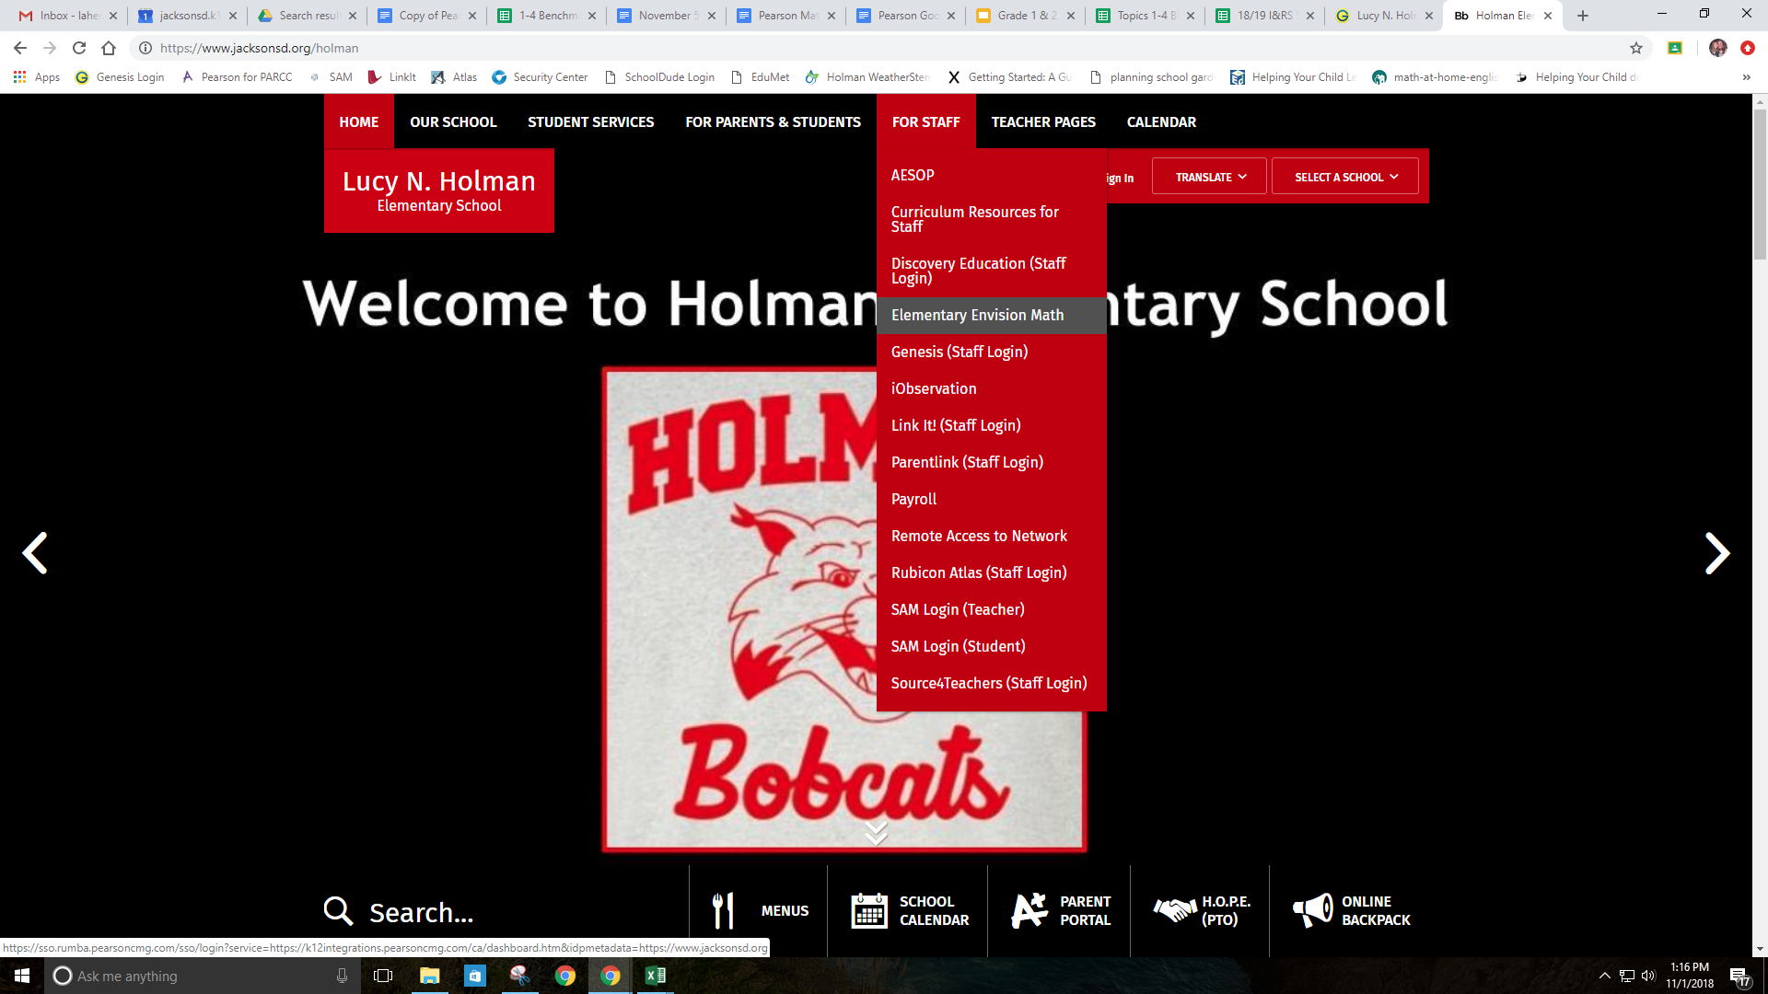

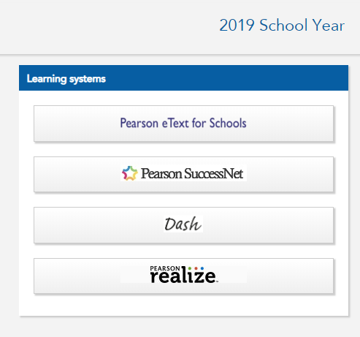

1. Click Pearson Realize on the right side and you’re ready to get your math on!

